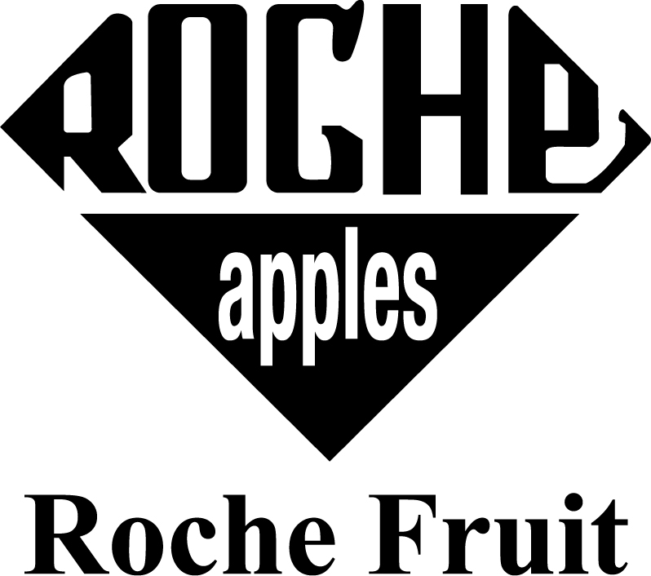

|  |  |  |  |  |  |  |  |  |  |  |  |  |  |  |
| --- | --- | --- | --- | --- | --- | --- | --- | --- | --- | --- | --- | --- | --- | --- |
| **Food Protection, Health, & Safety Employee Training Record**  **.** | | | | | | | | | | | | | | |
|  |  |  | | | |  |  | | |  | DVD  Oral/Written Presentation  (Attach Presentation Documents) | | |
| **Date** |  | **Training Location** | | | |  | **Trainer** | | | | Demonstration  Trainer | | |
| **Interpreter (Sign Here)_________________________**  Employee | | | | | | | | | | | | | |
|  | | |  |  |  | | | |  | | | |
| **Type of Training** | | | | | | | | | | | | | | |
| Accident Prevention Program | | | | | | | | Personal Protective Equipment | | | | Ergonomics | | |
| General Safety | | | | | | | | Labor Discussion | | | | Employee Health | | |
| Food Safety | | | | | | | | Lifting Safety | | | | Cleaning SSOP | | |
| Hazard Communication | | | | | | | | Forklift Safety | | | | Fall Protection | | |
| Emergency Info/ First Aid | | | | | | | | Heat Stress | | | | Aerial Lift Safety | | |
| Harvest Rules/Practices | | | | | | | | Cold Stress | | | | Other: Blood Borne Pathogen | | |
| Platform Safety | | | | | | | | Motor Vehicles | | | | Other: Q3 Pre Harvest Training | | |
| Other: Wildfire Smoke AQI above 101 | | | | | | | | | | | | | | |

|  |
| --- |
| **Wildfire Smoke Training**  As you all know wildfires and wildfire smoke appear to be more common each summer in the Pacific Northwest and LNI has released new standards for wildfire smoke as it relates to employee health and the environment where they work. The standards are summarized below and are required to be taught to all supervisors and employees that work outdoors. **N95 masks are required to be available to employees to wear on a voluntary basis, this is not required for them.**  1.) Supervisors must be trained to know how to take emergency action if someone is experiencing severe symptoms  - Stop worker  - Assess the condition of the worker and document symptoms  - Provide a rest area for worker with filtered air ( vehicle with cabin air filter, building with hvac and is sealed,  - Contact ambulance if condition of employee worsens.  2.) Communicate wildfire smoke conditions to employees & how they should protect themselves  - It would be smart to document this announcement to validate our efforts in case LNI was to question us  - Protective measures on this farm include:  • Reducing work time in areas with unfiltered air.  • When possible, increasing rest time and frequency, and providing a rest area with filtered air.  • If possible, reducing the physical intensity of the work to help lower the breathing and heart rates.  • Providing N95 masks for voluntary use by any employee when wildfire smoke reaches an air concentration of AQI 69.  3.) Hazards and risks associated with wildfire smoke :  - Greater concentrations of particulate matter in the air create more of a hazard for workers.  - Symptoms that may be the result of wildfire smoke exposure such as asthma attacks, and chest pain.  - Other symptoms include irritate the lungs and cause persistent coughing, phlegm, wheezing, or difficulty breathing.  - Workers who are in a sensitive related group (someone with: a lung disease, cancer, pregnant, respiratory illness, diabetes, etc.) can experience more severe symptoms at lower AQI, such as AQI 69.  - Particulate matter can also cause more serious problems, such as reduced lung function, bronchitis, worsening of asthma, heart failure, and early death  - How to wear a N95 respirator correctly (snug and airtight with sealcheck), how to maintain N95 (dispose after use) |

|  |  |
| --- | --- |
| **By Signing Below I Understand The Training**  **Al Firmar Abajo Entiendo La Capacitacion** | |
| **Employee Name (Print) Nombres De Empleados (Nombre Impresso)** | **Employee Name (Print) Nombres De Empleados (Nombre Impresso** |
|  |  |
|  |  |
|  |  |
|  |  |
|  |  |
|  |  |
|  |  |
|  |  |
|  |  |
|  |  |
|  |  |
|  |  |
|  |  |
|  |  |
|  |  |
|  |  |
|  |  |
|  |  |
|  |  |
|  |  |
|  |  |
|  |  |
|  |  |

|  |  |
| --- | --- |
| **By Signing Below I Understand The Training**  **Al Firmar Abajo Entiendo La Capacitacion** | |
| **Employee Name (Print) Nombres De Empleados (Nombre Impresso)** | **Employee Name (Print) Nombres De Empleados (Nombre Impresso** |
|  |  |
|  |  |
|  |  |
|  |  |
|  |  |
|  |  |
|  |  |
|  |  |
|  |  |
|  |  |
|  |  |
|  |  |
|  |  |
|  |  |
|  |  |
|  |  |
|  |  |
|  |  |
|  |  |
|  |  |
|  |  |
|  |  |
|  |  |